**PERFORMANCE REPORT**

**After running each test you have to repopulate the database .**

All the performance test has been executed in the Developer VM with the next configuration:

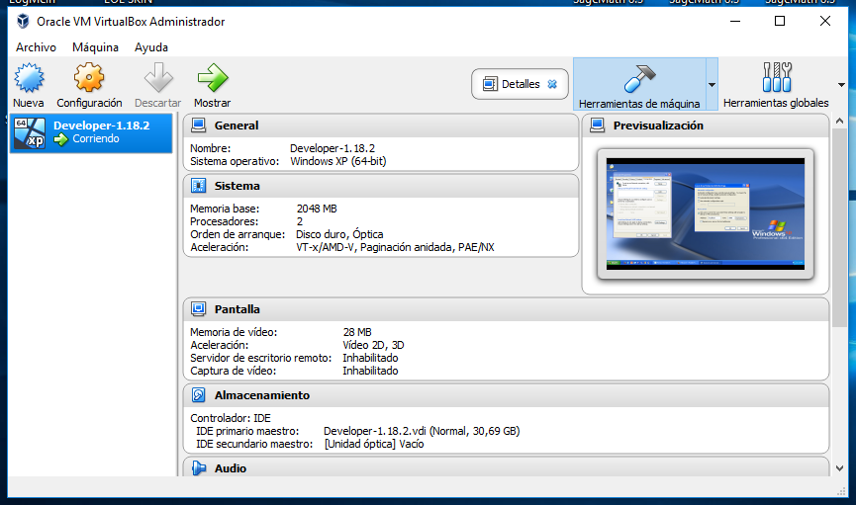

We have to set the proxy configuration as the following picture to run the test in the Developer VM:

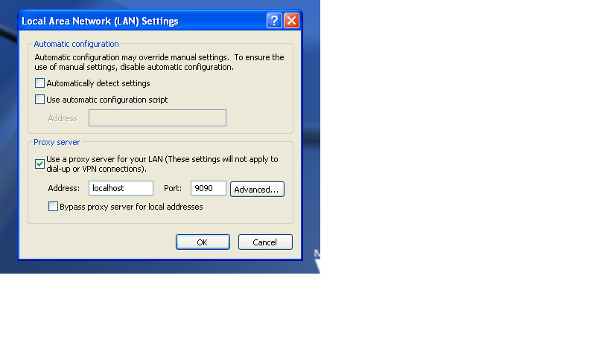

# Index

Index 2

UC29.1 Register reader test 3

UC29.1 Register organizar test 4

UC29.1 Register referee test 5

UC29.1 Register sponsor test 6

UC29.1 Register administrator test 7

# UC29.1 Register reader test

Aggregate Report

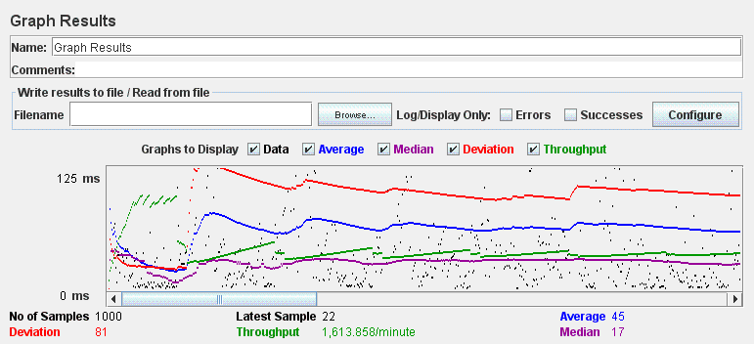

Graph Result

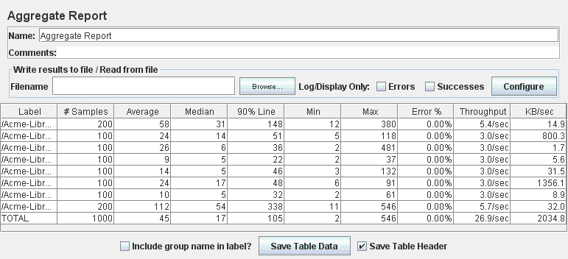

# UC29.1 Register organizer test

Aggregate Report

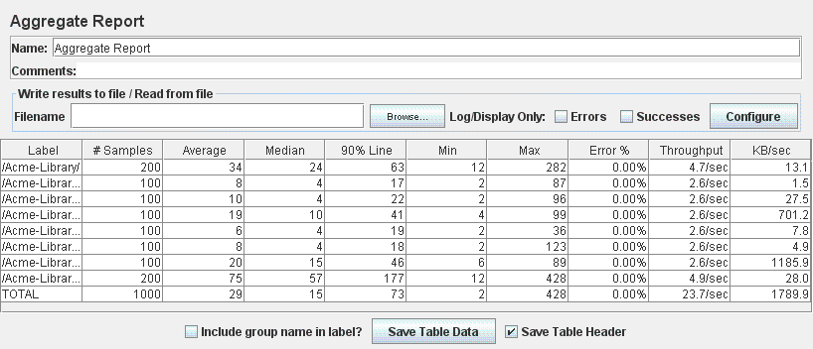

Graph Result

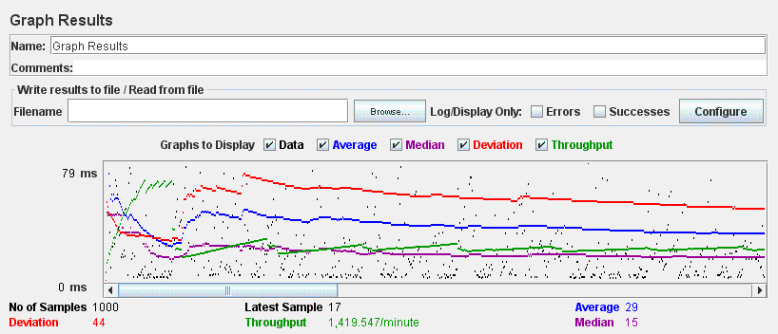

# UC35.11 Register referee test

Aggregate Report

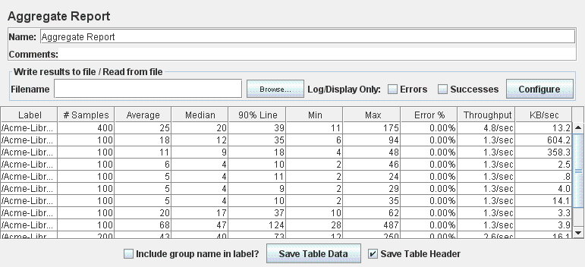

Graph Result

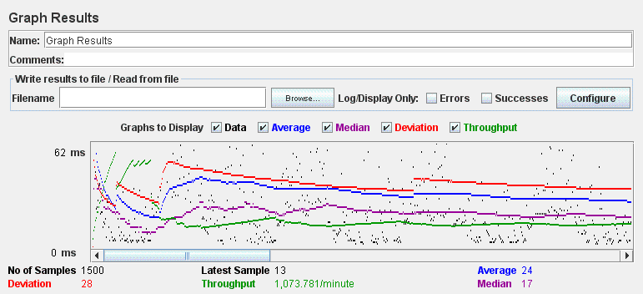

# UC29.1 Register sponsor test

Aggregate Report

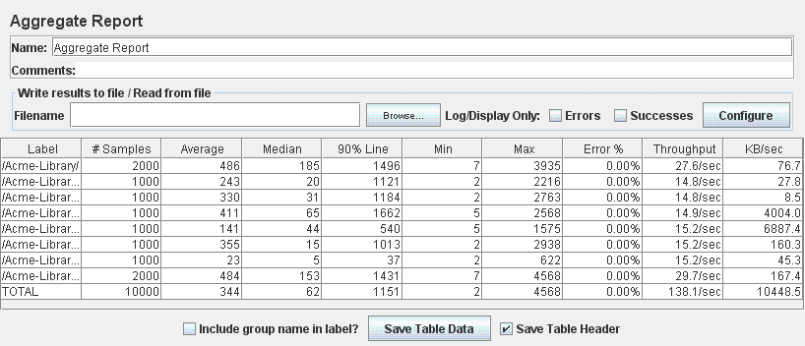

Graph Result

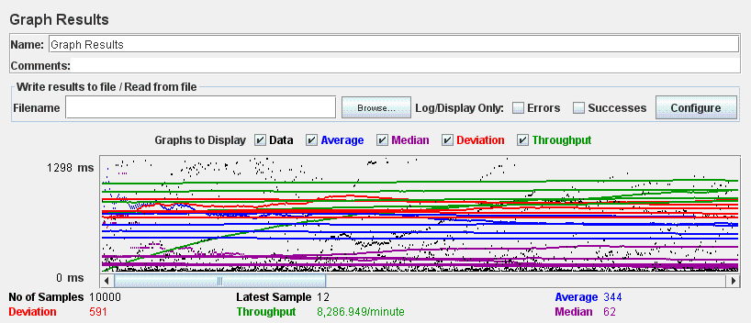

# UC35.1 Register administrator test

Aggregate Report

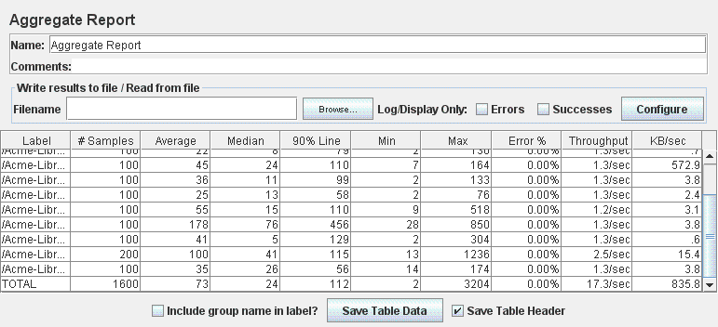

Graph Result

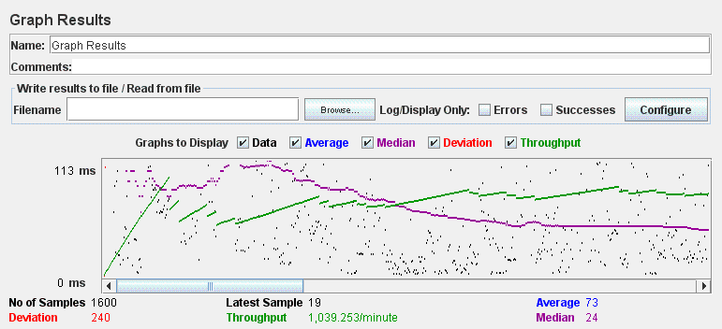

# UC30.2 Edit administrator test

Aggregate Report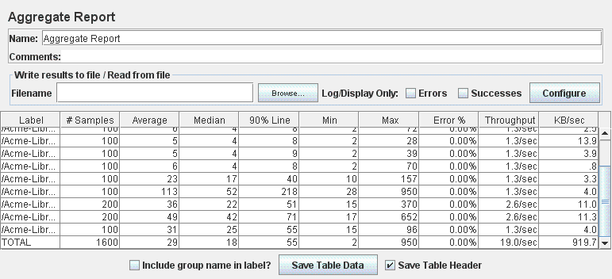

Graph Result

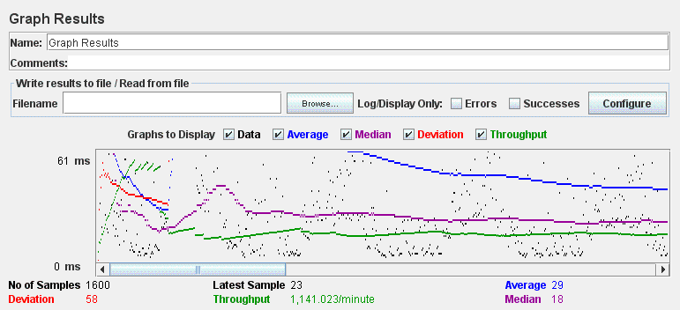

# UC30.2 Edit organizer test

Aggregate Report

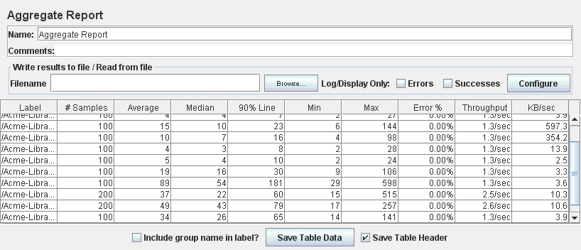

Graph Result

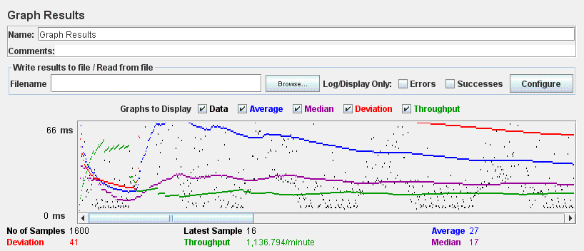

# UC30.2 Edit reader test

Aggregate Report

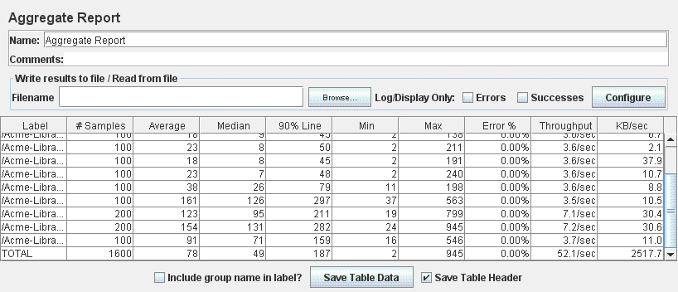

Graph Result

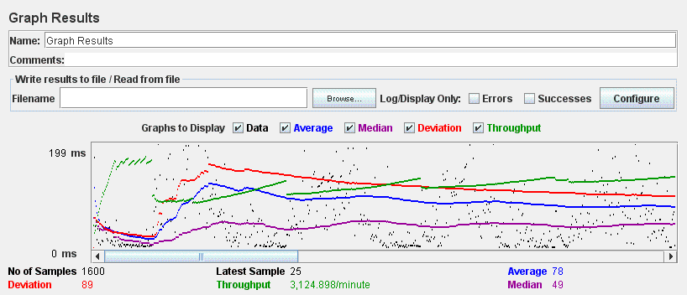

# UC30.2 Edit referee test

Aggregate Report

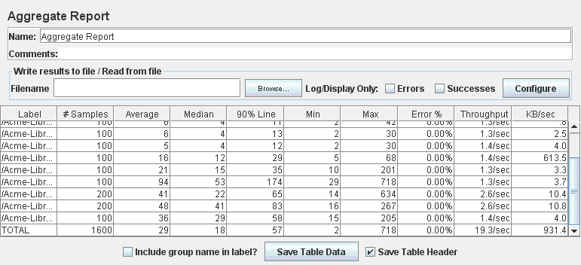

Graph Result

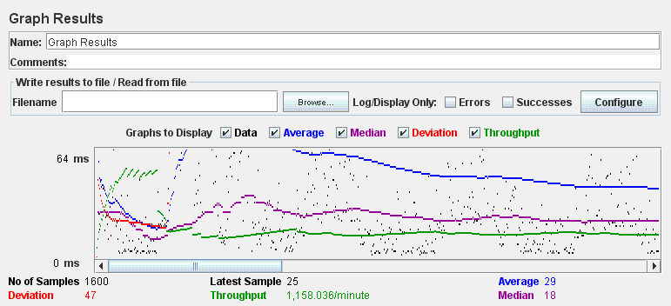

# UC30.2 Edit sponsor test

Aggregate Report

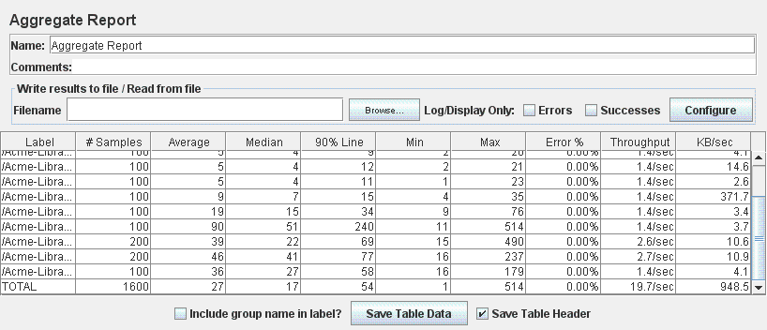

Graph Result

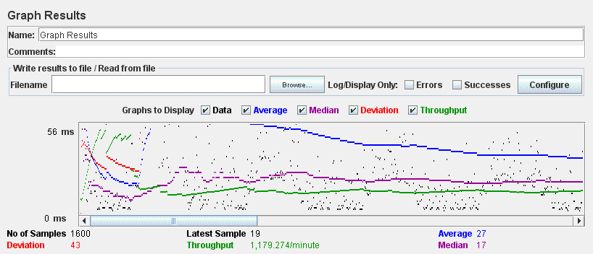

# UC30.3 Manage Social Profiles Test

Aggregate Report

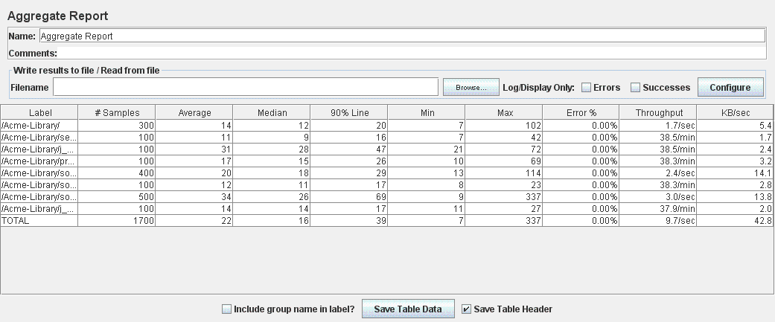

Graph Result

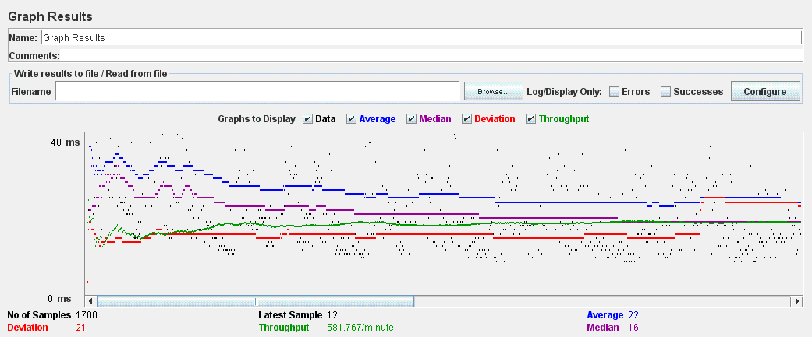

# UC30.4 Manage Messages test

Aggregate Report

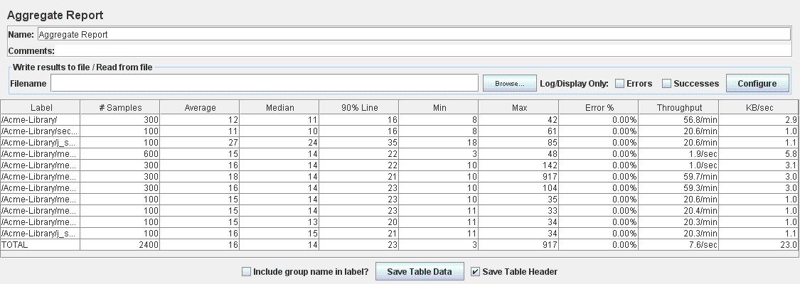

Graph Result

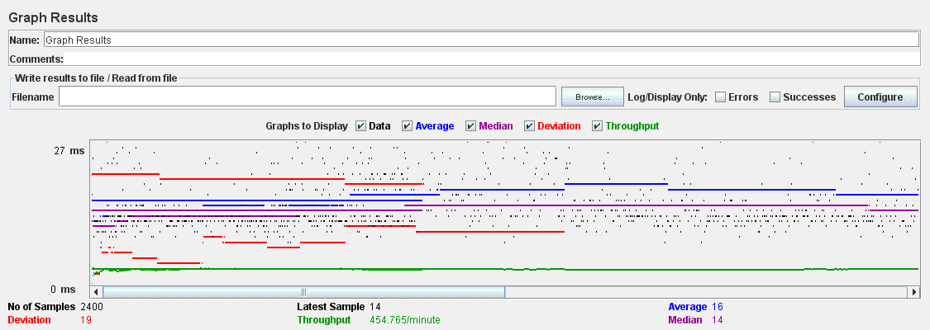

# UC30.5 Manage Messages Boxes test

Aggregate Report

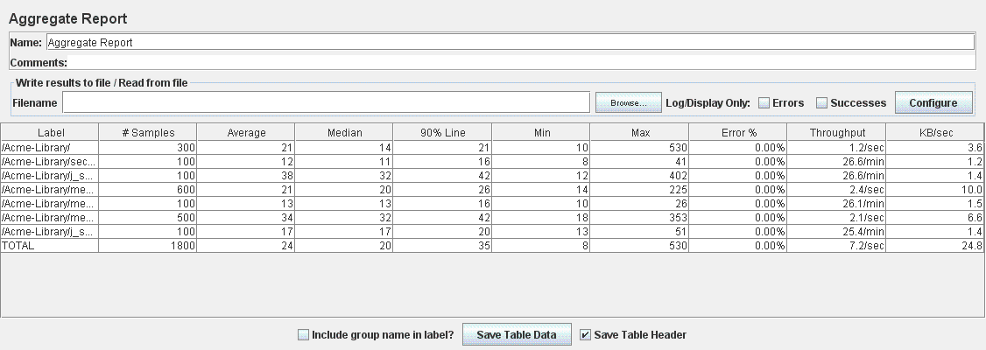

Graph Result

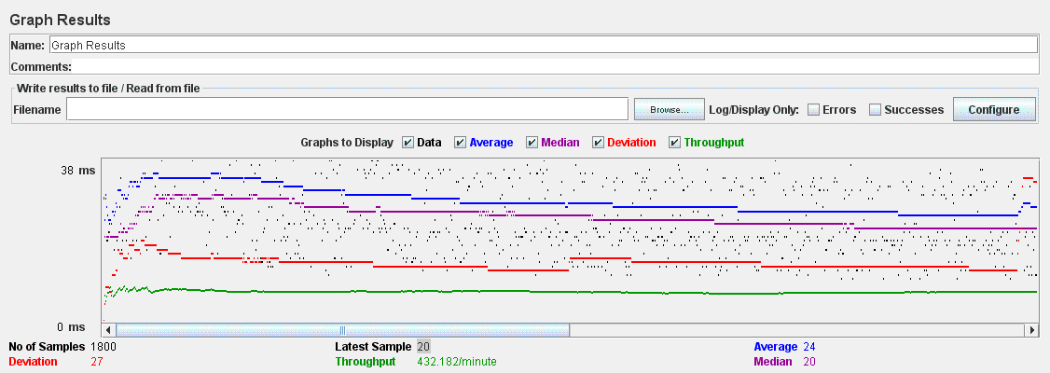

# UC31.1 Manage Books test

Aggregate Report

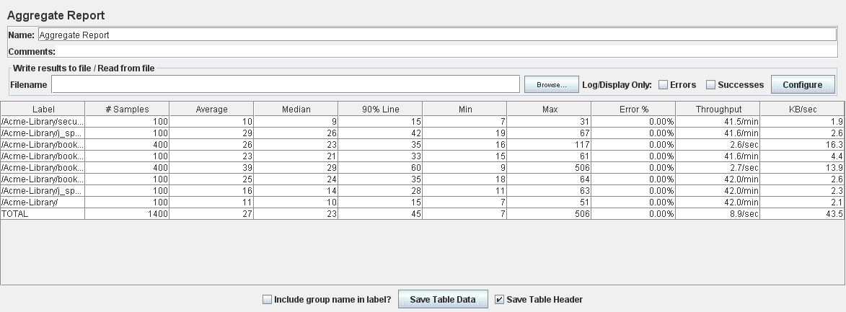

Graph Result

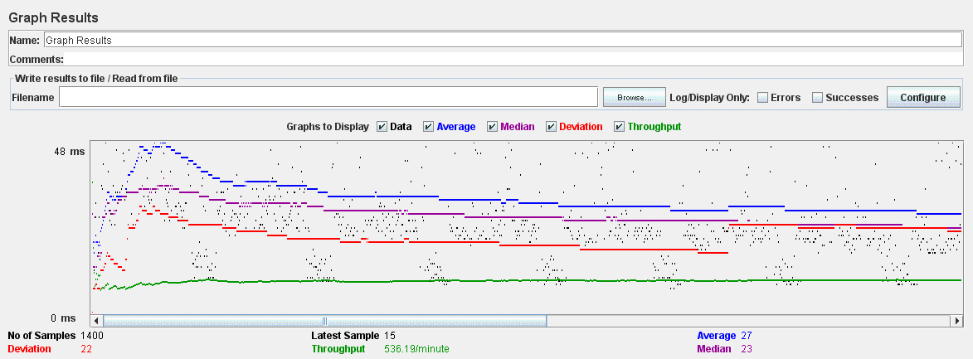

# UC31.2 Buy Sale Test

Aggregate Report

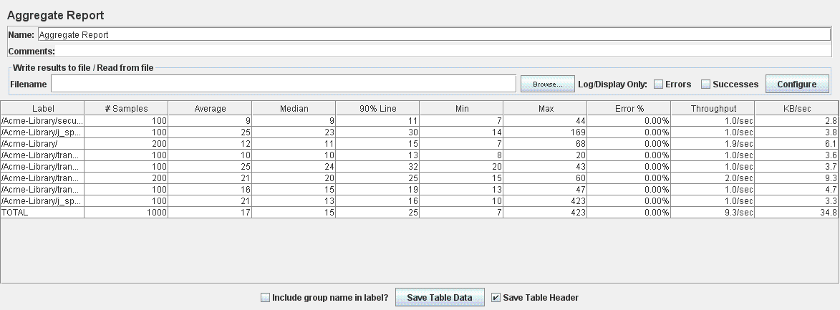

Graph Result

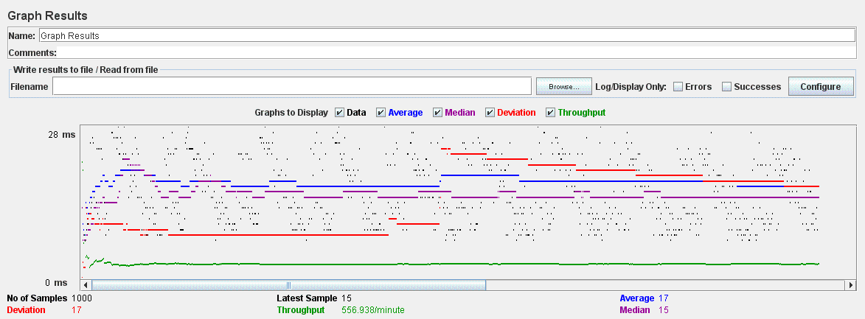

# UC31.2 Create Exchange test

Aggregate Report

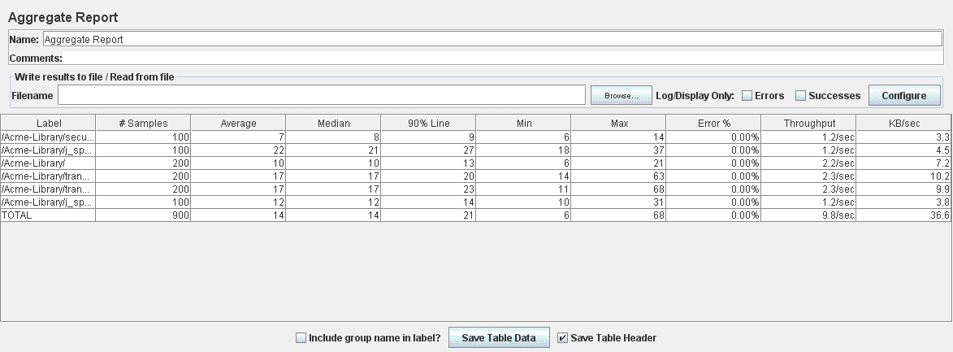

Graph Result

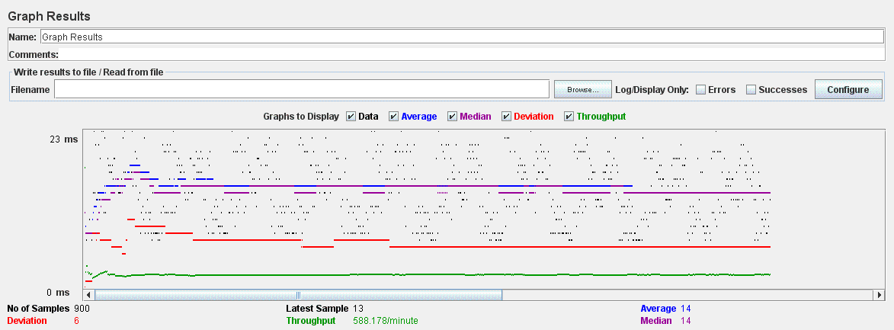

# UC31.2 Offer test

Aggregate Report

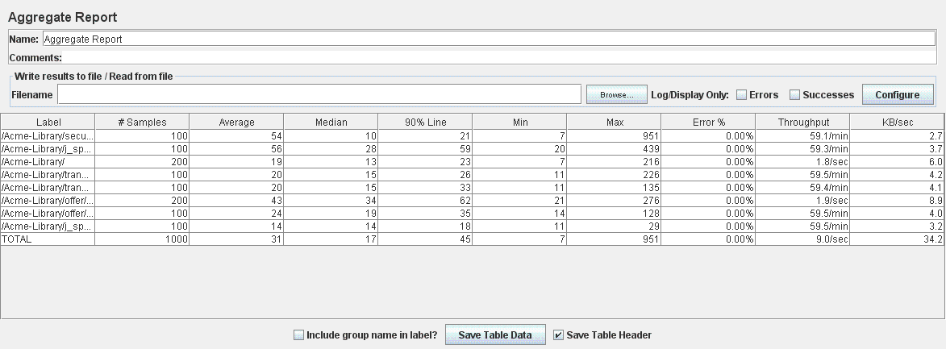

Graph Result

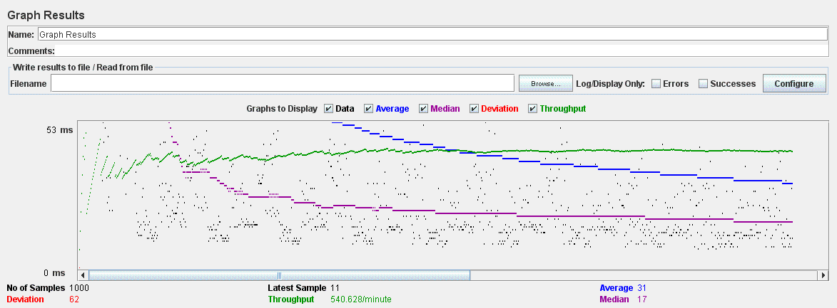

# UC31.3 Cleaning Finder test

Aggregate Report

Graph Result

# UC31.3 Updating Finder test

Aggregate Report

Graph Result

# UC31.4 Complaint test

Aggregate Report

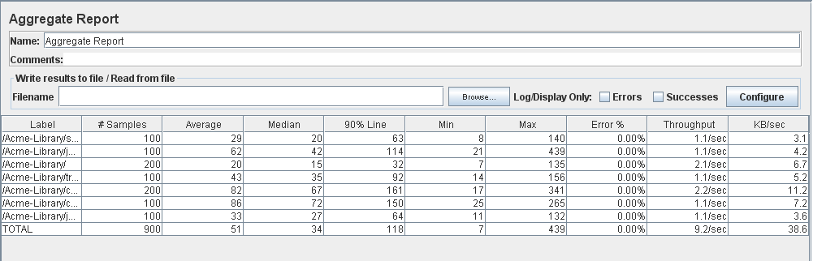

Graph Result

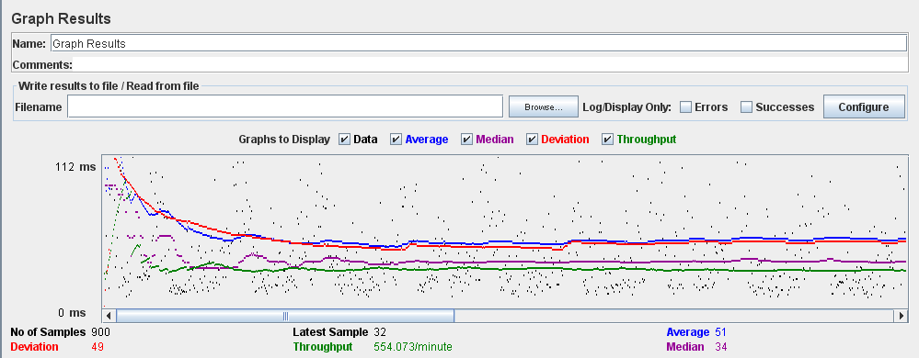

# UC31.4 Comment test

Aggregate Report

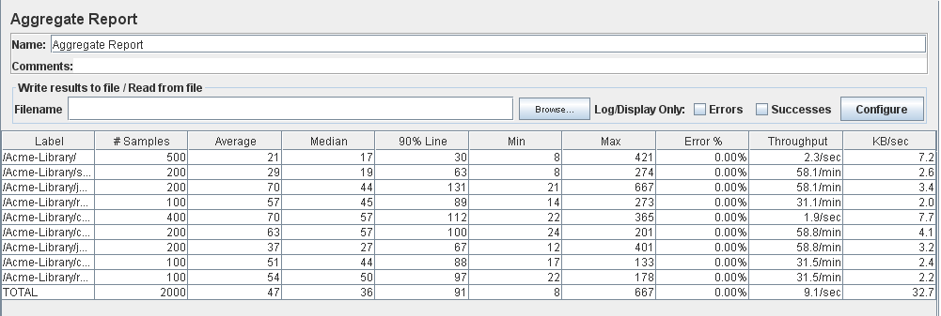

Graph Result

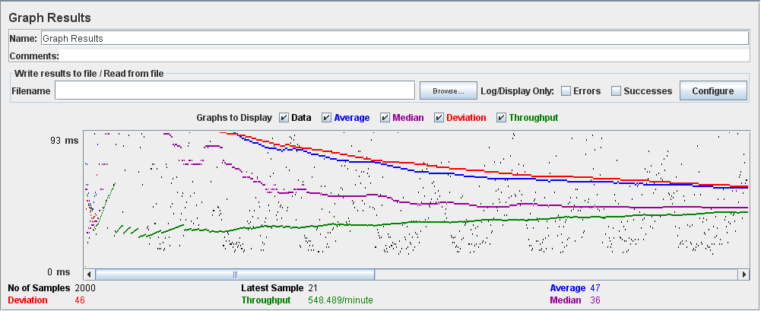

# UC32.1 Manage Event test

Aggregate Report

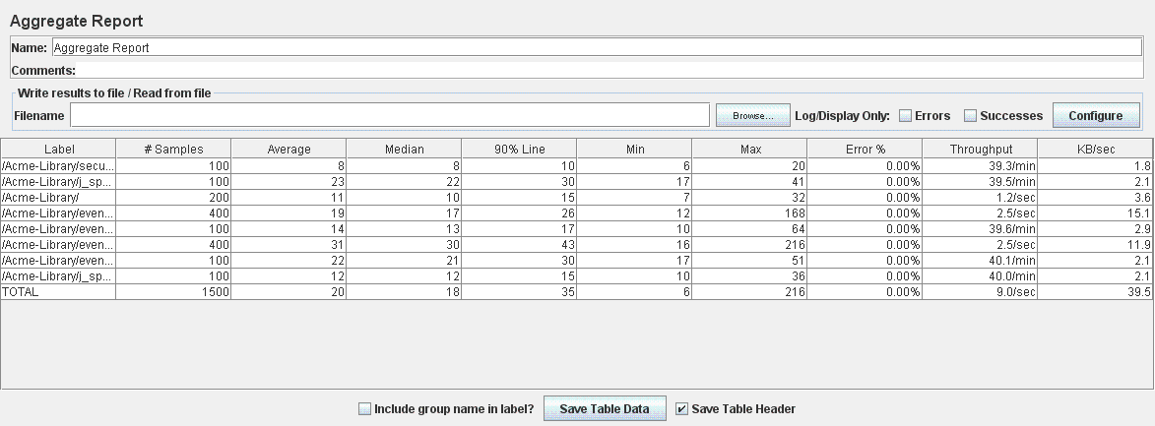

Graph Result

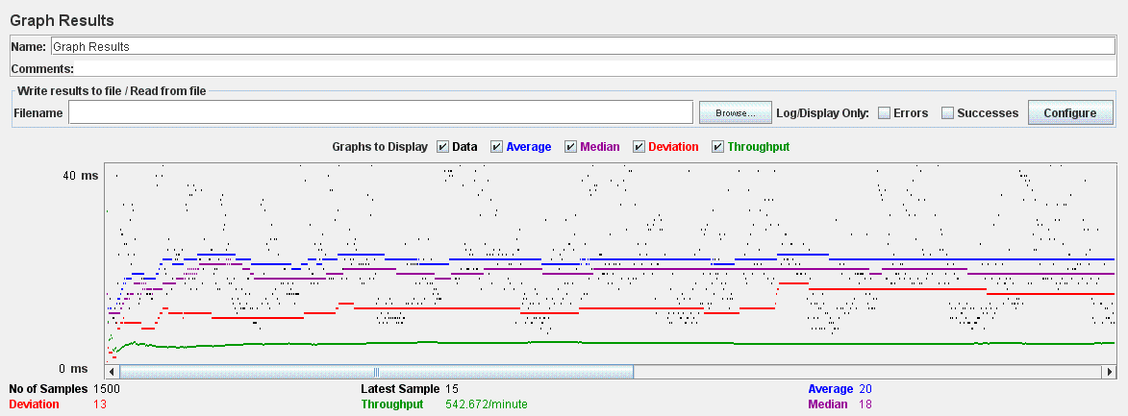

# Register Event test

Aggregate Report

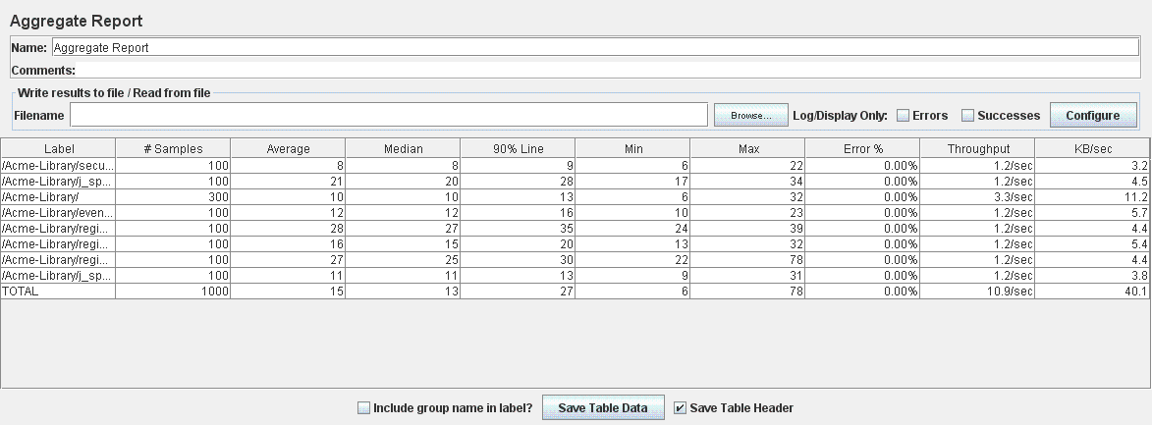

Graph Result

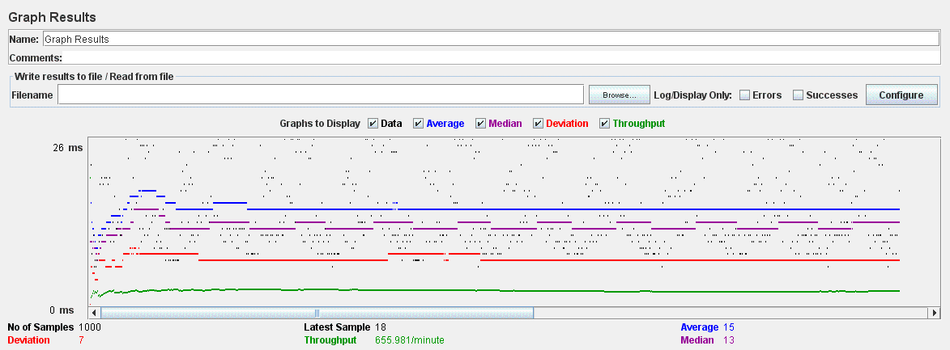

# UC33.1 Manage Sponsorships test

Aggregate Report

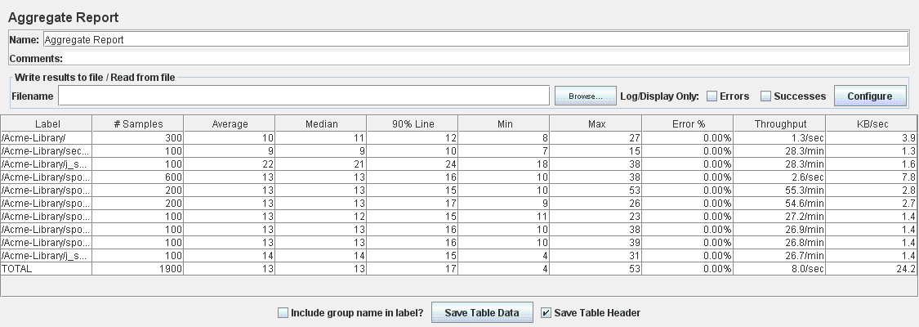

Graph Result

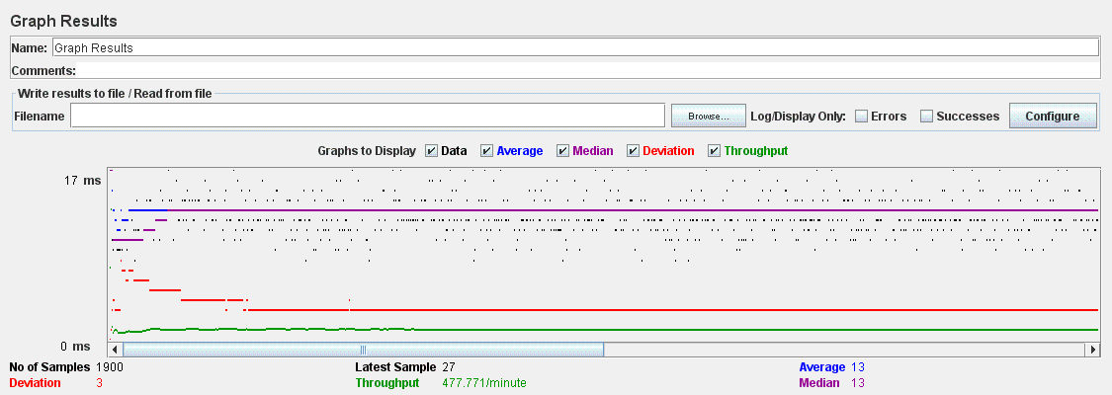

# UC34.1,UC34.2,UC34.3 Report test

Aggregate Report

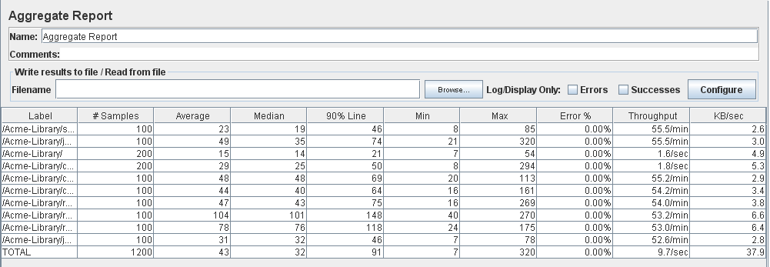

Graph Result

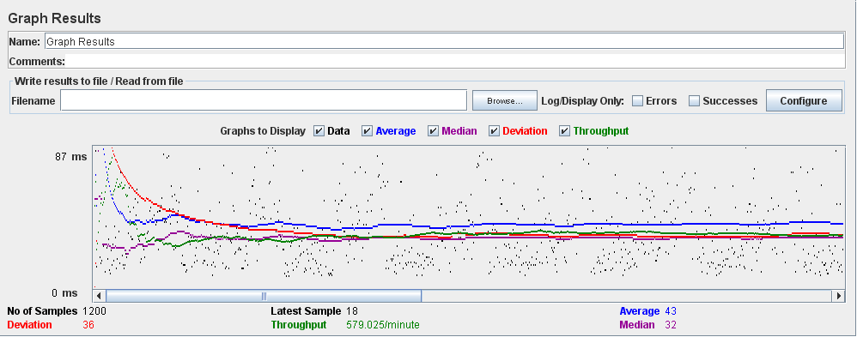

# UC35.2 Manage Category test

Aggregate Report

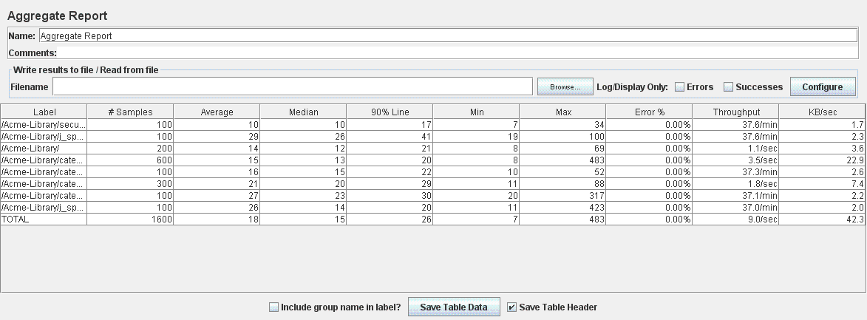

Graph Result

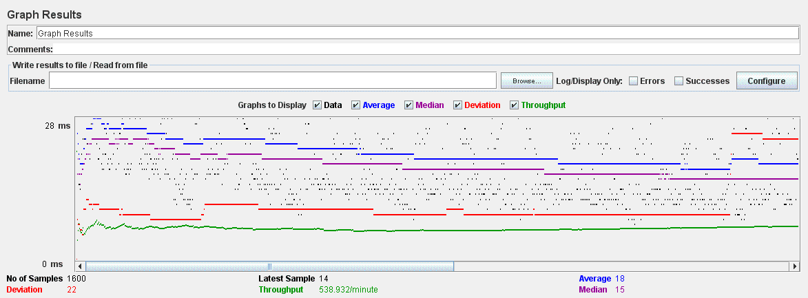

# UC35.3 Broadcast test

Aggregate Report

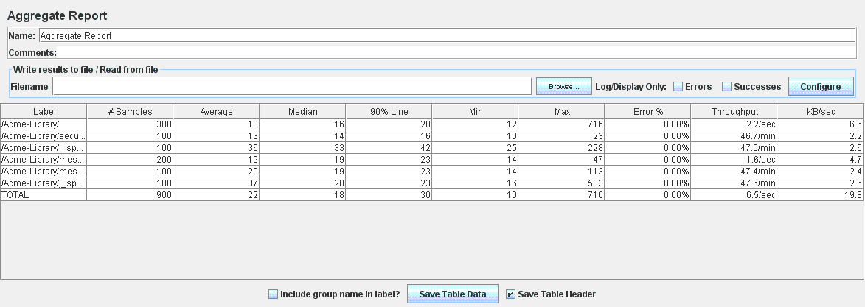

Graph Result

